Logistic Regression

Probability = Outcomes of interest / all possible outcomes

Example : coin flip(heads) = ½ = 0.5

Odds = probability of occurring / probability of not occurring

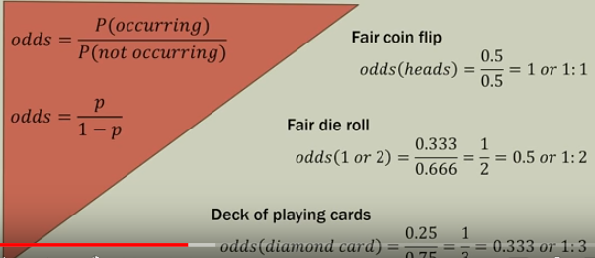

Odds ratio = Odds1 /Odds2

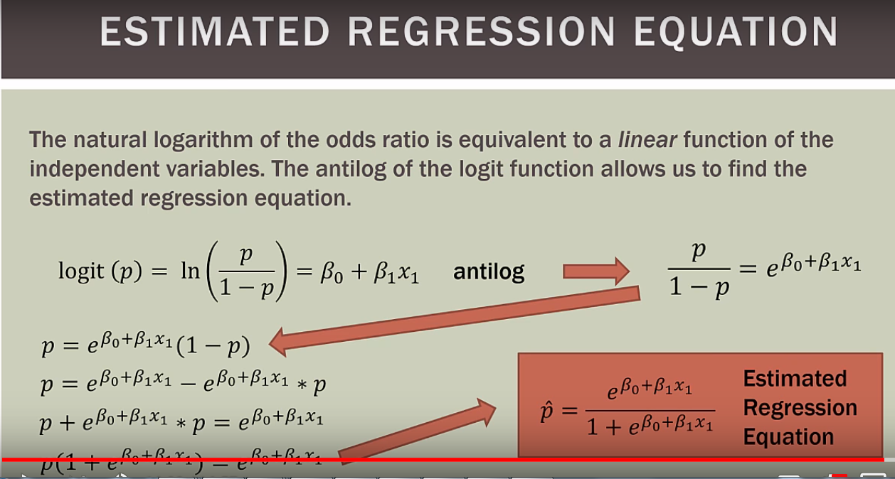

Find odds ratio

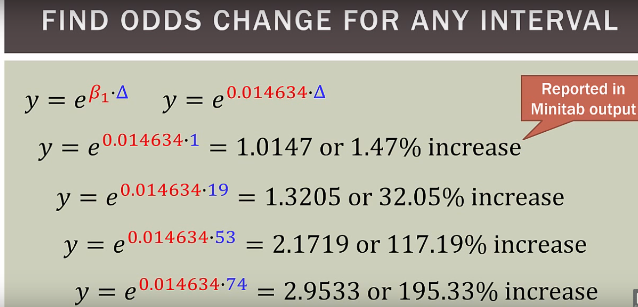

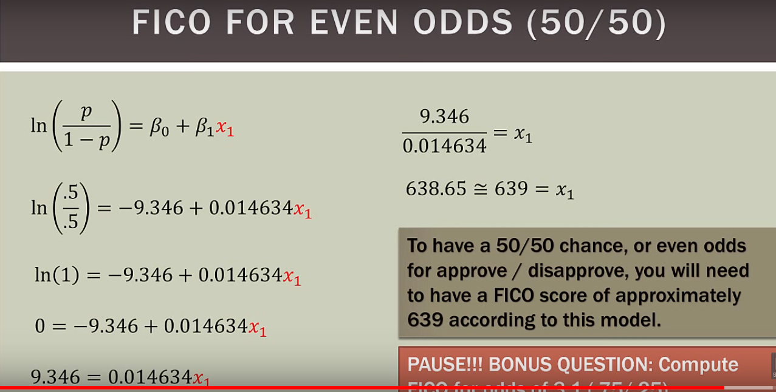

Logistic function

